Cloud Architect

Business Applications

**Lab Details**

1. This lab walks you through creating an SES Email notification in the AWS management console.
2. Duration: **15 minutes**
3. AWS Region: **US East (N. Virginia) us-east-1**

**Architecture Diagram**

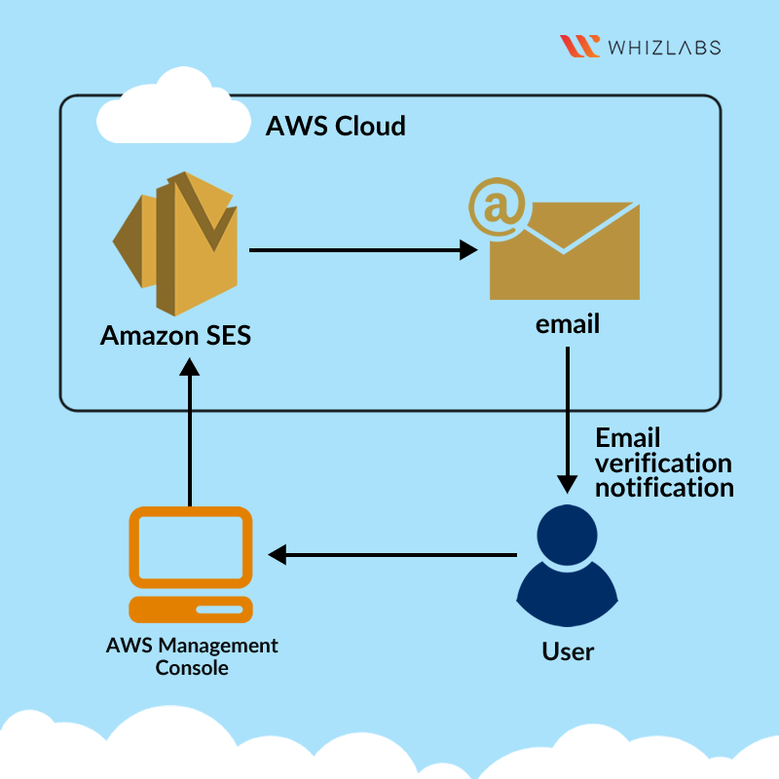

**Task Details**

1. Sign into AWS Management Console.
2. Create an Email Identity using SES.
3. Verify the Email address.
4. Send a Test Email.
5. Validation of the lab

**Launching Lab Environment**

     1. To launch the lab environment, Click on the  button.

     2. Please wait until the cloud environment is provisioned. It will take less than a minute to provision.

     3. Once the Lab is started, you will be provided with **IAM user name**, **Password**, **Access** **Key**, and **Secret** **Access** **Key**.

**Note** : You can only start one lab at any given time